Function work flow example

Yi-Han Tang

2021/4/23

The package will used in this example

library(ggplot2)  
library(dplyr)

##   
## Attaching package: 'dplyr'

## The following objects are masked from 'package:stats':  
##   
## filter, lag

## The following objects are masked from 'package:base':  
##   
## intersect, setdiff, setequal, union

library(yihanfinalproject)

Read the data and input it into R.

data<- read.csv(file.choose(),header = TRUE)  
  
data

## participants gender age height weight.1..Before. weight.2..after.  
## 1 1 M 35 181 102 92  
## 2 2 F 20 186 85 76  
## 3 3 M 14 170 85 75  
## 4 4 F 75 164 104 94  
## 5 5 M 60 182 84 75  
## 6 6 F 88 164 88 80  
## 7 7 M 43 157 90 82  
## 8 8 F 22 156 103 93  
## 9 9 M 10 112 117 107  
## 10 10 F 22 167 80 72  
## 11 11 M 20 162 115 110  
## 12 12 F 55 153 85 79  
## 13 13 F 65 171 113 108  
## 14 14 M 55 165 91 87  
## 15 15 F 45 167 120 115  
## 16 16 M 42 173 108 103  
## 17 17 M 44 183 82 79  
## 18 18 F 49 169 103 100  
## 19 19 F 87 155 91 89  
## 20 20 M 78 164 102 99  
## 21 21 F 32 158 98 95  
## 22 22 F 12 140 91 88  
## 23 23 F 7 124 28 23  
## 24 24 M 15 155 108 105  
## 25 25 M 88 164 109 107  
## 26 26 M 60 172 96 94  
## 27 27 F 73 155 99 96  
## 28 28 M 43 160 104 101  
## 29 29 F 33 163 119 116  
## 30 30 M 59 175 114 111  
## 31 31 M 34 178 96 96  
## 32 32 F 57 170 82 82  
## 33 33 M 65 170 107 107  
## 34 34 F 24 160 80 80  
## 35 35 M 22 169 93 93  
## 36 36 M 17 173 97 97  
## 37 37 F 9 128 23 23  
## 38 38 F 60 154 78 78  
## 39 39 M 5 103 20 20  
## 40 40 F 33 171 99 99  
## drug_frequency  
## 1 5  
## 2 5  
## 3 5  
## 4 5  
## 5 5  
## 6 5  
## 7 5  
## 8 5  
## 9 5  
## 10 5  
## 11 3  
## 12 3  
## 13 3  
## 14 3  
## 15 3  
## 16 3  
## 17 3  
## 18 3  
## 19 3  
## 20 3  
## 21 1  
## 22 1  
## 23 1  
## 24 1  
## 25 1  
## 26 1  
## 27 1  
## 28 1  
## 29 1  
## 30 1  
## 31 0  
## 32 0  
## 33 0  
## 34 0  
## 35 0  
## 36 0  
## 37 0  
## 38 0  
## 39 0  
## 40 0

Calculate the two BMI(before & after) of participants by using function cal_bmi() and insert new column for the results

data$first_BMI <- cal_bmi(data$height, data$weight.1..Before.)  
data$second_BMI <-cal_bmi(data$height, data$weight.2..after.)  
  
data

## participants gender age height weight.1..Before. weight.2..after.  
## 1 1 M 35 181 102 92  
## 2 2 F 20 186 85 76  
## 3 3 M 14 170 85 75  
## 4 4 F 75 164 104 94  
## 5 5 M 60 182 84 75  
## 6 6 F 88 164 88 80  
## 7 7 M 43 157 90 82  
## 8 8 F 22 156 103 93  
## 9 9 M 10 112 117 107  
## 10 10 F 22 167 80 72  
## 11 11 M 20 162 115 110  
## 12 12 F 55 153 85 79  
## 13 13 F 65 171 113 108  
## 14 14 M 55 165 91 87  
## 15 15 F 45 167 120 115  
## 16 16 M 42 173 108 103  
## 17 17 M 44 183 82 79  
## 18 18 F 49 169 103 100  
## 19 19 F 87 155 91 89  
## 20 20 M 78 164 102 99  
## 21 21 F 32 158 98 95  
## 22 22 F 12 140 91 88  
## 23 23 F 7 124 28 23  
## 24 24 M 15 155 108 105  
## 25 25 M 88 164 109 107  
## 26 26 M 60 172 96 94  
## 27 27 F 73 155 99 96  
## 28 28 M 43 160 104 101  
## 29 29 F 33 163 119 116  
## 30 30 M 59 175 114 111  
## 31 31 M 34 178 96 96  
## 32 32 F 57 170 82 82  
## 33 33 M 65 170 107 107  
## 34 34 F 24 160 80 80  
## 35 35 M 22 169 93 93  
## 36 36 M 17 173 97 97  
## 37 37 F 9 128 23 23  
## 38 38 F 60 154 78 78  
## 39 39 M 5 103 20 20  
## 40 40 F 33 171 99 99  
## drug_frequency first_BMI second_BMI  
## 1 5 31.13458 28.08217  
## 2 5 24.56931 21.96786  
## 3 5 29.41176 25.95156  
## 4 5 38.66746 34.94943  
## 5 5 25.35926 22.64219  
## 6 5 32.71862 29.74420  
## 7 5 36.51264 33.26707  
## 8 5 42.32413 38.21499  
## 9 5 93.27168 85.29974  
## 10 5 28.68514 25.81663  
## 11 3 43.81954 41.91434  
## 12 3 36.31082 33.74770  
## 13 3 38.64437 36.93444  
## 14 3 33.42516 31.95592  
## 15 3 43.02772 41.23490  
## 16 3 36.08540 34.41478  
## 17 3 24.48565 23.58984  
## 18 3 36.06316 35.01278  
## 19 3 37.87721 37.04475  
## 20 3 37.92385 36.80845  
## 21 1 39.25653 38.05480  
## 22 1 46.42857 44.89796  
## 23 1 18.21020 14.95838  
## 24 1 44.95317 43.70447  
## 25 1 40.52647 39.78287  
## 26 1 32.44997 31.77393  
## 27 1 41.20708 39.95838  
## 28 1 40.62500 39.45312  
## 29 1 44.78904 43.65990  
## 30 1 37.22449 36.24490  
## 31 0 30.29920 30.29920  
## 32 0 28.37370 28.37370  
## 33 0 37.02422 37.02422  
## 34 0 31.25000 31.25000  
## 35 0 32.56189 32.56189  
## 36 0 32.41004 32.41004  
## 37 0 14.03809 14.03809  
## 38 0 32.88919 32.88919  
## 39 0 18.85192 18.85192  
## 40 0 33.85657 33.85657

Check the qualify of each participants (the weight should use weight 1). Increase a column to show the results. After that, using filter() to filter the participants who are “Eligile”.

data$checkstate <- check_check(data$age, data$height, data$weight.1..Before.)  
  
newdata <- filter(data, data$checkstate == "Eligile")  
  
newdata

## participants gender age height weight.1..Before. weight.2..after.  
## 1 1 M 35 181 102 92  
## 2 4 F 75 164 104 94  
## 3 5 M 60 182 84 75  
## 4 6 F 88 164 88 80  
## 5 7 M 43 157 90 82  
## 6 8 F 22 156 103 93  
## 7 10 F 22 167 80 72  
## 8 12 F 55 153 85 79  
## 9 13 F 65 171 113 108  
## 10 14 M 55 165 91 87  
## 11 15 F 45 167 120 115  
## 12 16 M 42 173 108 103  
## 13 18 F 49 169 103 100  
## 14 19 F 87 155 91 89  
## 15 20 M 78 164 102 99  
## 16 21 F 32 158 98 95  
## 17 25 M 88 164 109 107  
## 18 26 M 60 172 96 94  
## 19 27 F 73 155 99 96  
## 20 28 M 43 160 104 101  
## 21 29 F 33 163 119 116  
## 22 30 M 59 175 114 111  
## 23 31 M 34 178 96 96  
## 24 32 F 57 170 82 82  
## 25 33 M 65 170 107 107  
## 26 34 F 24 160 80 80  
## 27 35 M 22 169 93 93  
## 28 38 F 60 154 78 78  
## 29 40 F 33 171 99 99  
## drug_frequency first_BMI second_BMI checkstate  
## 1 5 31.13458 28.08217 Eligile  
## 2 5 38.66746 34.94943 Eligile  
## 3 5 25.35926 22.64219 Eligile  
## 4 5 32.71862 29.74420 Eligile  
## 5 5 36.51264 33.26707 Eligile  
## 6 5 42.32413 38.21499 Eligile  
## 7 5 28.68514 25.81663 Eligile  
## 8 3 36.31082 33.74770 Eligile  
## 9 3 38.64437 36.93444 Eligile  
## 10 3 33.42516 31.95592 Eligile  
## 11 3 43.02772 41.23490 Eligile  
## 12 3 36.08540 34.41478 Eligile  
## 13 3 36.06316 35.01278 Eligile  
## 14 3 37.87721 37.04475 Eligile  
## 15 3 37.92385 36.80845 Eligile  
## 16 1 39.25653 38.05480 Eligile  
## 17 1 40.52647 39.78287 Eligile  
## 18 1 32.44997 31.77393 Eligile  
## 19 1 41.20708 39.95838 Eligile  
## 20 1 40.62500 39.45312 Eligile  
## 21 1 44.78904 43.65990 Eligile  
## 22 1 37.22449 36.24490 Eligile  
## 23 0 30.29920 30.29920 Eligile  
## 24 0 28.37370 28.37370 Eligile  
## 25 0 37.02422 37.02422 Eligile  
## 26 0 31.25000 31.25000 Eligile  
## 27 0 32.56189 32.56189 Eligile  
## 28 0 32.88919 32.88919 Eligile  
## 29 0 33.85657 33.85657 Eligile

Summay each group(drug frequency) and input extra participants to each group have same participants

count(newdata, drug_frequency)

## drug_frequency n  
## 1 0 7  
## 2 1 7  
## 3 3 8  
## 4 5 7

data2 <-read.csv(file.choose(),header = TRUE)  
#calculate BMI(before & after)  
data2$first_BMI <- cal_bmi(data2$height, data2$weight.1..Before.)  
data2$second_BMI <-cal_bmi(data2$height, data2$weight.2..after.)  
#check qualify  
data2$checkstate <- check_check(data2$age, data2$height, data2$weight.1..Before.)  
  
#combine two dataframe  
total <- rbind(newdata, data2)  
  
head(total)

## participants gender age height weight.1..Before. weight.2..after.  
## 1 1 M 35 181 102 92  
## 2 4 F 75 164 104 94  
## 3 5 M 60 182 84 75  
## 4 6 F 88 164 88 80  
## 5 7 M 43 157 90 82  
## 6 8 F 22 156 103 93  
## drug_frequency first_BMI second_BMI checkstate  
## 1 5 31.13458 28.08217 Eligile  
## 2 5 38.66746 34.94943 Eligile  
## 3 5 25.35926 22.64219 Eligile  
## 4 5 32.71862 29.74420 Eligile  
## 5 5 36.51264 33.26707 Eligile  
## 6 5 42.32413 38.21499 Eligile

# organize dataframe  
arrange(total,drug_frequency)

## participants gender age height weight.1..Before. weight.2..after.  
## 1 31 M 34 178 96 96  
## 2 32 F 57 170 82 82  
## 3 33 M 65 170 107 107  
## 4 34 F 24 160 80 80  
## 5 35 M 22 169 93 93  
## 6 38 F 60 154 78 78  
## 7 40 F 33 171 99 99  
## 8 49 M 76 173 107 107  
## 9 50 M 66 161 80 80  
## 10 51 M 27 170 96 96  
## 11 21 F 32 158 98 95  
## 12 25 M 88 164 109 107  
## 13 26 M 60 172 96 94  
## 14 27 F 73 155 99 96  
## 15 28 M 43 160 104 101  
## 16 29 F 33 163 119 116  
## 17 30 M 59 175 114 111  
## 18 46 F 79 156 70 68  
## 19 47 M 81 154 71 68  
## 20 48 M 56 179 109 105  
## 21 12 F 55 153 85 79  
## 22 13 F 65 171 113 108  
## 23 14 M 55 165 91 87  
## 24 15 F 45 167 120 115  
## 25 16 M 42 173 108 103  
## 26 18 F 49 169 103 100  
## 27 19 F 87 155 91 89  
## 28 20 M 78 164 102 99  
## 29 44 F 32 166 80 75  
## 30 45 M 56 173 95 90  
## 31 1 M 35 181 102 92  
## 32 4 F 75 164 104 94  
## 33 5 M 60 182 84 75  
## 34 6 F 88 164 88 80  
## 35 7 M 43 157 90 82  
## 36 8 F 22 156 103 93  
## 37 10 F 22 167 80 72  
## 38 41 M 47 182 110 100  
## 39 42 F 26 185 115 105  
## 40 43 M 37 171 95 85  
## drug_frequency first_BMI second_BMI checkstate  
## 1 0 30.29920 30.29920 Eligile  
## 2 0 28.37370 28.37370 Eligile  
## 3 0 37.02422 37.02422 Eligile  
## 4 0 31.25000 31.25000 Eligile  
## 5 0 32.56189 32.56189 Eligile  
## 6 0 32.88919 32.88919 Eligile  
## 7 0 33.85657 33.85657 Eligile  
## 8 0 35.75128 35.75128 Eligile  
## 9 0 30.86301 30.86301 Eligile  
## 10 0 33.21799 33.21799 Eligile  
## 11 1 39.25653 38.05480 Eligile  
## 12 1 40.52647 39.78287 Eligile  
## 13 1 32.44997 31.77393 Eligile  
## 14 1 41.20708 39.95838 Eligile  
## 15 1 40.62500 39.45312 Eligile  
## 16 1 44.78904 43.65990 Eligile  
## 17 1 37.22449 36.24490 Eligile  
## 18 1 28.76397 27.94214 Eligile  
## 19 1 29.93759 28.67263 Eligile  
## 20 1 34.01891 32.77051 Eligile  
## 21 3 36.31082 33.74770 Eligile  
## 22 3 38.64437 36.93444 Eligile  
## 23 3 33.42516 31.95592 Eligile  
## 24 3 43.02772 41.23490 Eligile  
## 25 3 36.08540 34.41478 Eligile  
## 26 3 36.06316 35.01278 Eligile  
## 27 3 37.87721 37.04475 Eligile  
## 28 3 37.92385 36.80845 Eligile  
## 29 3 29.03179 27.21730 Eligile  
## 30 3 31.74179 30.07117 Eligile  
## 31 5 31.13458 28.08217 Eligile  
## 32 5 38.66746 34.94943 Eligile  
## 33 5 25.35926 22.64219 Eligile  
## 34 5 32.71862 29.74420 Eligile  
## 35 5 36.51264 33.26707 Eligile  
## 36 5 42.32413 38.21499 Eligile  
## 37 5 28.68514 25.81663 Eligile  
## 38 5 33.20855 30.18959 Eligile  
## 39 5 33.60117 30.67933 Eligile  
## 40 5 32.48863 29.06877 Eligile

Use total(dataset) to see the different results by different varies. First, to see the BMI distribution of participants of different ages by using finction plotage(). And using plotage_separate() to see in different drug frequency, the age distribution of participants.

Before1 <- plotage(total$age,total$height, total$weight.1..Before., total$drug_frequency)  
After1 <- plotage(total$age, total$height, total$weight.2..after.,total$drug_frequency)  
  
Before1

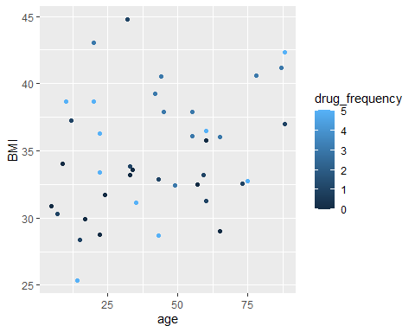

After1

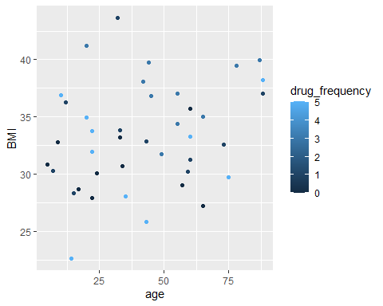

Before_separte1 <- plotage_separate(total, total$age,total$height, total$weight.1..Before., total$drug_frequency)  
After_separte1 <- plotage_separate(total, total$age, total$height, total$weight.2..after.,total$drug_frequency)  
  
Before_separte1

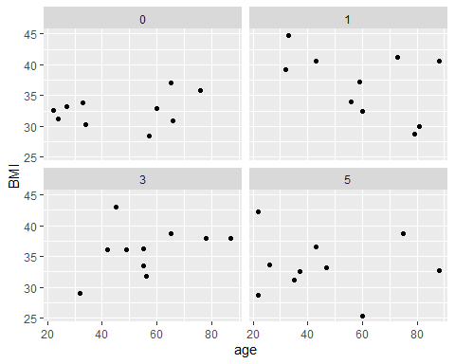

After_separte1

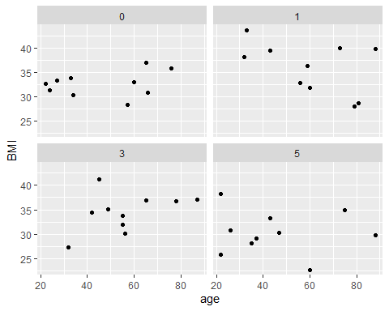

Using plotgender() and plotgender_separate() to see the different results by gender.

genderbefore <-plotgender(total$age, total$height, total$weight.1..Before.)  
genderafter <- plotgender(total$age, total$height, total$weight.2..after.)  
  
genderbefore

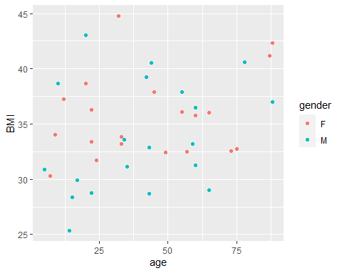

genderafter

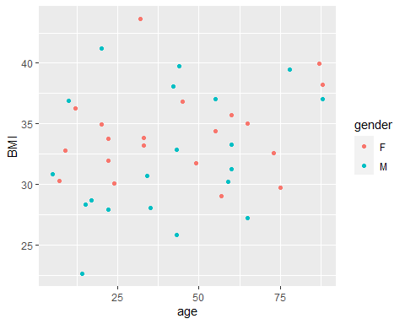

# using plotgender_separate() to separate in different plots  
  
genderbeforese <-plotgender_separate(total, total$age, total$height, total$weight.1..Before., total$gender)  
genderafterse <- plotgender_separate(total,total$age, total$height, total$weight.2..after., total$gender )  
  
genderbeforese

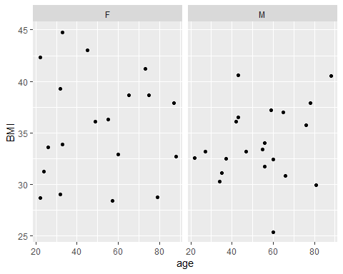

genderafterse

